Hi all,

This is my assignment 1 submission.Thanks for checking.

Kind regards,

Heng Rui

**Task 1** Describe the MCU chip on the board of**Arduino Uno,** name**the type、number of pins、footprint and the main functions?**

任务1 描述Arduino Uno板上的单片机芯片，说出其类型、引脚数、脚印和主要功能。

Answer：

单片机芯片

类型：DIP14，双列直插式

引脚数：14个

脚印：AVR？

主要功能：blinking（通过I/O进行电频控制）；

通信功能（串行；蓝牙；WiFi）;

//Shield

**Task 2**Two LEDs are respectively linked with the**digital pins of D11 and D12**, make code to let them both**blinking every second**.

任务2 两个LED分别与D11和D12的数字引脚相连，编写代码让它们每秒钟闪烁一次。

Answer:

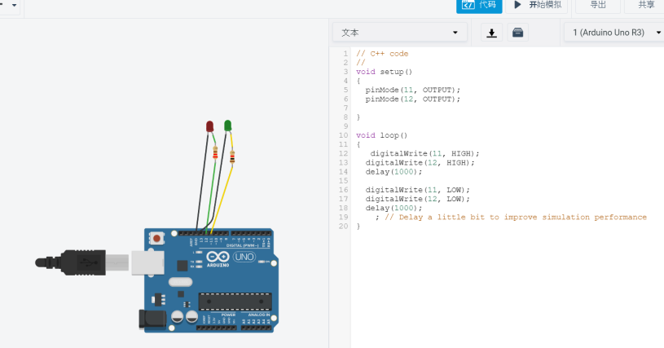

Gif:

**Code:**

**// C++ code**

**//**

**/\***

**This program blinks pin 13 of the Arduino (the built-in LED)**

**\*/**

**void setup()**

**{**

**pinMode(11, OUTPUT);**

**pinMode(12, OUTPUT);**

**}**

**void loop()**

**{**

**digitalWrite(11, HIGH);**

**digitalWrite(12, HIGH);**

**delay(1000);**

**digitalWrite(11, LOW);**

**digitalWrite(12, LOW);**

**delay(1000);**

**}**